Project Design Phase-II
Data Flow Diagram & User Stories

Date | 30 September 2026
Team ID | SWTID-2026-5468
Project Name | Implement Client Script & UI Policy (Incident)
Maximum Marks | 4 Marks

Data Flow Diagrams:
A Data Flow Diagram (DFD) is a traditional visual representation of the information flows within a system. A neat and clear DFD can depict the right amount of the system requirement graphically. It shows how data enters and leaves the system, what changes the information, and where data is stored.
Example: DFD Level 0 (Industry Standard)
Example: (Simplified)



User Stories
Use the below template to list all the user stories for the product.
User Type | Functional Requirement (Epic) | User Story Number | User Story / Task | Acceptance criteria | Priority | Release
Service Desk Agent | High Impact Control | USN-1 | As a service desk agent, I can see Assignment group become mandatory when Impact is High, so that high impact incidents are always routed. | Assignment group is mandatory when Impact = 1 - High | High | Sprint-1
Service Desk Agent | High Impact Control | USN-2 | As a service desk agent, I cannot edit Urgency while Impact is High, so that it stays consistent with the impact. | Urgency is visible but read-only when Impact = High | High | Sprint-1
Service Desk Agent | Auto Urgency | USN-3 | As a service desk agent, I want Urgency to be set to High automatically when I set Impact to High, so that I do not have to set it manually. | Urgency changes to 1 - High as soon as Impact is set to High | High | Sprint-1
Service Desk Agent | Auto Urgency | USN-4 | As a service desk agent, I want to see a message when Urgency is set automatically, so that I know why the value changed. | Message "Urgency set to High for High impact incident." is displayed | Medium | Sprint-1
Service Desk Agent | Save Validation | USN-5 | As a service desk agent, I am prevented from saving a High impact incident without Assigned To. | Error message is shown on Assigned To and the record is not saved | High | Sprint-2
Service Desk Agent | Save Validation | USN-6 | As a service desk agent, I can save a High impact incident once Assigned To is filled. | Record saves successfully with no errors | High | Sprint-2
Service Desk Agent | Reverse Condition | USN-7 | As a service desk agent, when I change Impact from High to Medium, the restrictions are removed. | Assignment group not mandatory, Urgency editable, record saves | Medium | Sprint-2
Service Desk Agent | Form Update | USN-8 | As a service desk agent, I can update State from the Incident form. | State change made on the form is saved successfully | Medium | Sprint-2
Incident Manager | Data Quality | USN-9 | As an incident manager, I want every High impact incident to have an owner, so that triage, SLA tracking and reporting are accurate. | No High impact incident can be saved without Assigned To | High | Sprint-2
Administrator | List Edit Restriction | USN-10 | As an administrator, I want State changes blocked in the list view, so that State is only changed through the form. | Alert is shown and the State value remains unchanged | Medium | Sprint-2
Administrator | Configuration | USN-11 | As an administrator, I can configure the UI Policy and Client Scripts from System UI, so that the rules can be maintained. | UI Policy and Client Scripts are active and listed under System UI | Medium | Sprint-1
Administrator | Testing | USN-12 | As an administrator, I can run the defined test scenarios to confirm all rules work together. | Mandatory, successful save, reverse condition, list edit and form update tests all pass | Low | Sprint-3

Project Data Flow Diagram - Level 0:
At Level 0 the whole solution is one process. The user provides incident details, the process controls field behaviour and validates the data, and only valid records reach the Incident table.
Project Data Flow Diagram - Level 1:
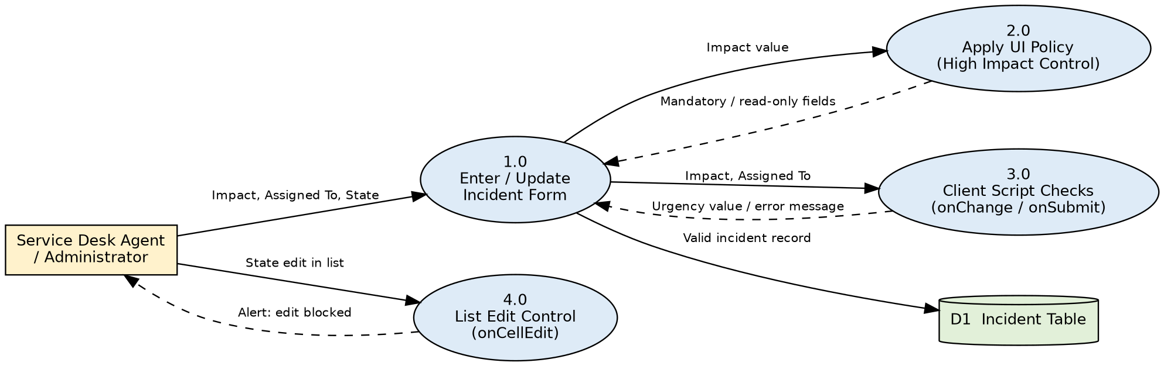
• 1.0 Enter / Update Incident Form: receives Impact, Assigned To and State from the user and passes them to the checks.
• 2.0 Apply UI Policy: uses the Impact value to make Assignment group mandatory and Urgency read-only, and reverses this when Impact changes.
• 3.0 Client Script Checks: onChange sets Urgency; onSubmit returns an error message when Assigned To is missing for High impact.
• 4.0 List Edit Control: onCellEdit blocks State edits made in the list and shows an alert.
• D1 Incident Table: stores only records that pass the checks.

